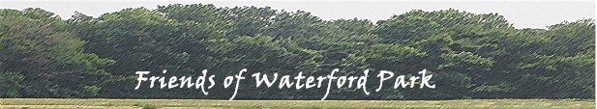

MEMBERSHIP AND DONATION FORM

Yes, I/we wish to join the Friends of Waterford Park. Enclosed are my / our membership dues for 2010. (Single membership $10; Household $25).

Names of member(s): _____________________________________________

Mailing address of member(s): ___________________________________________

Email of member(s) if you wish to receive updates of activities by email : __________________________________________

Phone number of member(s):____________________________

Yes, I / we would also like to support efforts of the Friends of Waterford Park with the enclosed donation or pledge.
[ ] $25.00 [ ] $50.00 [ ] $75.00 [ ] $100.00 [ ] Other __________
Make your checks for dues and/or donations payable to:
“The Friends of Baker Park”
in the check memo write:
“FWP account”

Your dues and donations will help fund the development of Waterford and Rock Creek Parks as passive neighborhood parks. The Friends of Baker Park is a 501(c)(3) corporation.

MAIL THIS FORM TO: Linda Berkheimer, Treasurer
1500 Rock Creek Drive
Frederick, MD 21702-4006
-------------------------------------------------------------------------------------------------------------

If you wish to discuss any special donations (such as for a bench or a large tree or any other improvement you would like us to consider), please contact Ginny Brace: mail - 1604 Rock Creek Drive; phone - 301-682-6135; email - info@friendsofwaterfordpark.org.

